Following our earlier conversation, I have the following feedback points on the training portal.

1. Uploading documents works to some extent, but I cannot upload the course brochure. Is there a limit on the size of the documents that can be uploaded?

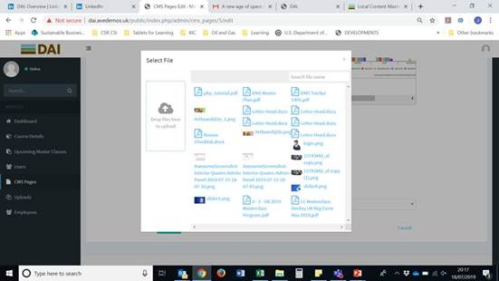

1. I tried to upload the brochure on the Uploads page, to see if it was an issue with the button on the Masterclass CMS page but it didn’t work here either:

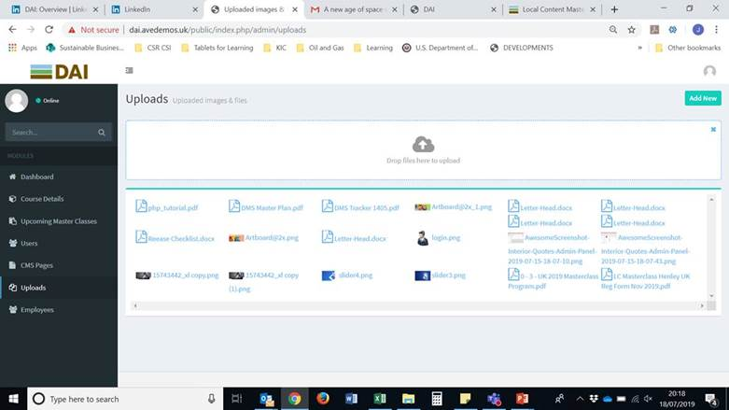

I have attached the course brochure to this email so that you can see the size of the file. It is the only reason I can think of that the system will not allow the upload as I was able to upload the other files. Can you please fix this.

1. Once I uploaded the registration form on Upcoming Masterclasses, when I try to click the link on the front end (Registration page), this happens:

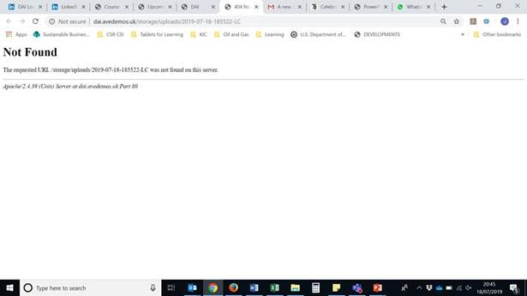

When I tried on Firefox, the box wouldn’t even click so I am not sure what the issue is here – certainly doesn’t appear that it is a Chrome issue.

1. Also, I notice that the only file type that it will allow me to upload are PDFs. The registration form is a Word document. How can I upload this?

1. On the Community of Practice page, there are a couple of issues with inserting the link for the LinkedIn page.

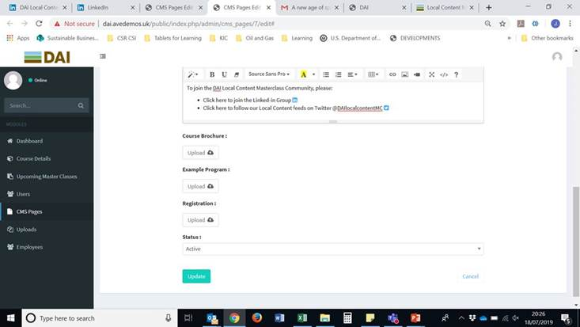

There is an icon for LinkedIn but to insert the link makes this icon disappear:

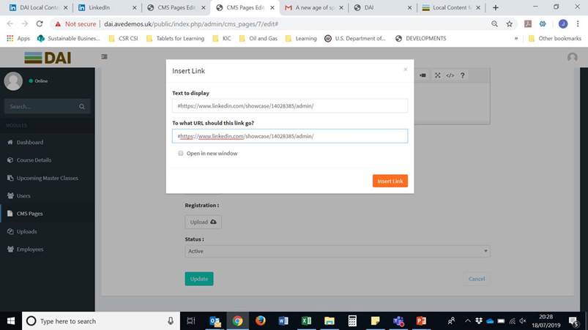

The Text to Display box copies whatever I insert into the second box so that the user end only shows the URL:

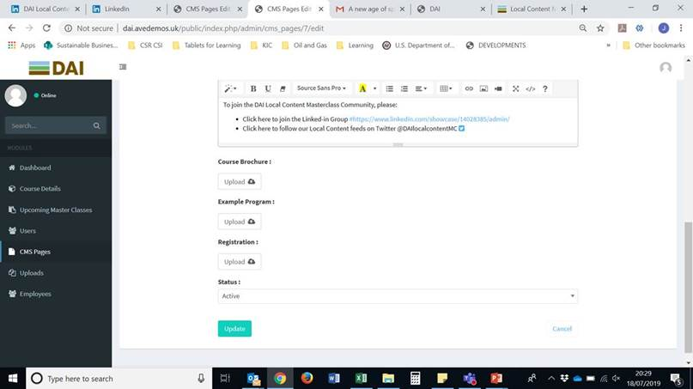

Which looks pretty terrible:

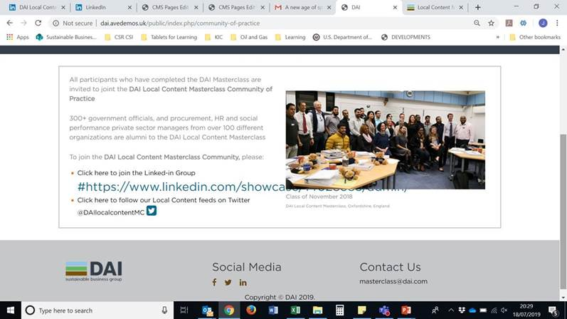

Moreover, when you click that hyperlink from the front end, this happens:

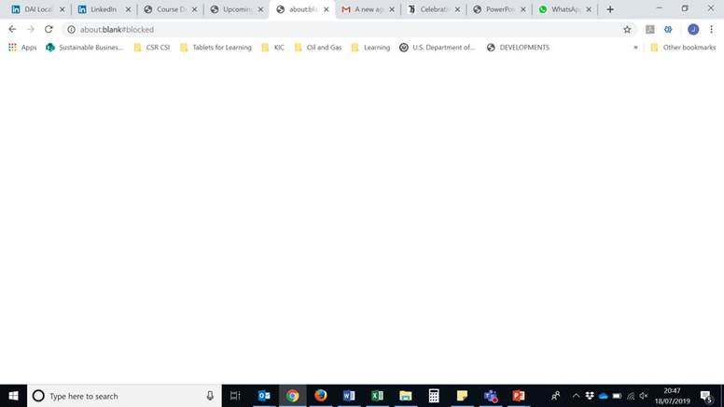

Also, on the admin side, why are there buttons to upload Course Brochure etc. on the Community of Practice admin page? These should not be here – please remove as they do not serve any function:

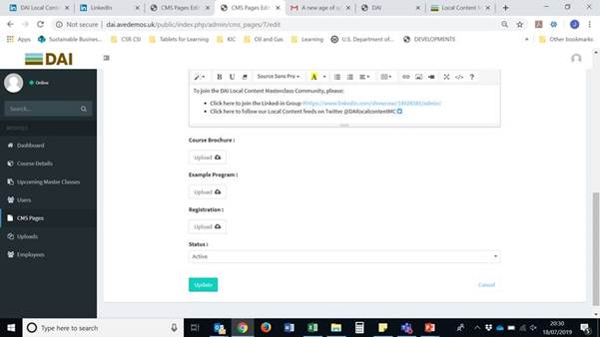

1. All of the CMS pages have the option to be Active or Inactive – please remove this option as I don’t want these pages to be accidentally removed from the front end:

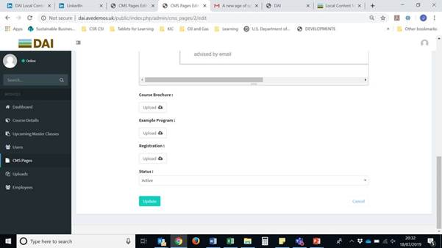

1. I am having some issues logging in. I created a username for myself and received an email with the password which I entered. At first it allowed me to do this on Firefox but not on Chrome. Various things have happened. First this:

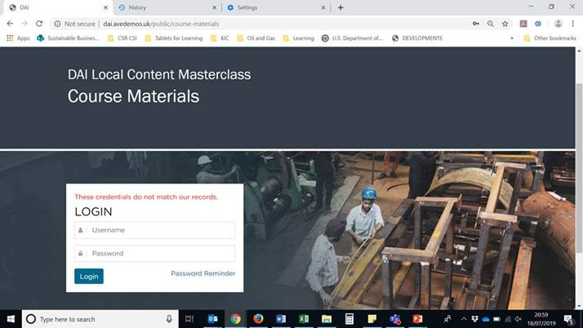

Even after I cleared the cache, this came up:

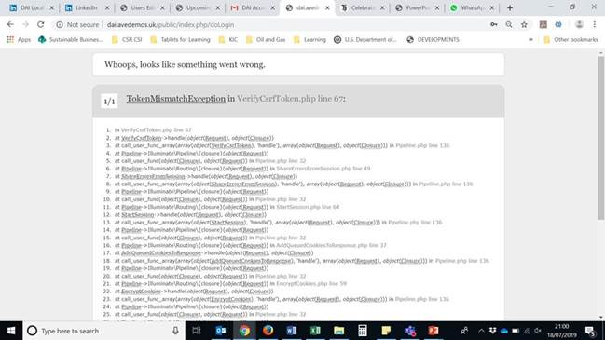

On Firefox I can get as far as this page but it will not allow me to click on the Course Materials button to download the files which I have uploaded on the admin side. Why is this button not working?

